Depression Detection using EEG
1. INTRODUCTION:
It has been announced by the World Health Organization (WHO) that according to the estimation, in excess of 322 million people all around the world suffer from depression by which this mental disorder has become the leading contributor to the causing of disability. Depressive patients are typically recognized by symptoms such as a feeling of sadness, hopelessness, and guilty, loss of interest, concentration, and energy, changes in appetite, sleep, and other routines .Poverty, unemployment, tragic events of life, physical disorders, and problems with alcohol or drug consumption are considered as determining factors leading to depression. Recently, the Covid 19 pandemic has advanced the cause of depression, and its consequent conditions such as imposing lockdown, going into quarantine, and practicing social distancing are considered other main reasons for experiencing depression.
With regard to the fact that depression poses an unprecedented threat to public health and have someadverse effects on depressive people such as committing suicide , and also considering this matter that early diagnosis can result in providing timely and more effective treatment, devising and developing an efficient and reliable method of depression detection or even prediction would be of the high importance.Electroencephalogram (EEG) signals which naturally have nonstationary, highly complex, non-invasive, and nonlinear structure, involves human brain activities and working status. Due to this complexity, available abnormality would be difficult to detect with the naked eyes. These properties have made physiological signals are deemed to be valuable tools for depression detection .
Deep learning is defined as a hierarchy structure with a series of algorithms which have some hidden neurons . These models provide computers with the ability of building complex concepts from simple statements . These learnt concepts utilize to build next layers. Furthermore, in these methods, multiple processing layers are responsible for pattern and data structure recognition .
This multi-layer method has been recently utilized in different applications of various fields, ranging from agriculture , automotive Industry , and IoT to diverse usage in medicine . Because deep learning architecture has the capability of automated learning and extracting features from input raw data, and regarding the limitation of machine learning techniques in this point , and also due to difficulties in manual EEG signals analyzing , adopting deep learning solutions has been more popular in the related occasions by which the implicit nonlinear features in EEG signals can extract with the least effort .
Applications of deep learning in depression diagnosis with the assistance of EEG signals have increased in recent times. The main purpose of this article is to conduct an SLR-based review of papers concentrated on deep learning usage in depression detection or prediction using EEG signals. To the best of our knowledge, there was no systematic literature review focused on the mentioned topic and our SLR survey is the pioneer in this field of research.
The important contributions of this review are as follow:
- Designing a complete taxonomy chart of all exploited deep learning algorithms
- Providing concise summaries of all studied researches and drawing a comparison between main aspects of them
- Propose a general pattern of five steps based on all reviewed papers and providing some information related to each stages to analyze them
- Highlighting open issues and future works for this purpose
1.1 Objective of the project:
Electroencephalogram (EEG) signals can be used to identify this mood disorder. It takes a lot of practise, is tiresome, and takes a long time to manually diagnose depression using EEG data. Therefore, a completely automated method for diagnosing depression built utilising EEG data will be useful to physicians.To predict sadness from a dataset of EEG waves, we are employing the deep learning CNN method in this study. Due to the intense competition in all spheres of life today, people are more likely to experience depression, and early identification of depression might hasten a person's recovery. All of the methods that were previously used required manual counselling, and outdated machine learning methods like SVM were ineffective. Using the CNN method, which filters trained data across several layers to produce optimum features, we may more correctly predict sadness.
2. LITERATURE SURVEY:
Anxiety and depression in COVID-19 survivors: role of inflammatory and clinical predictors
Infection-triggered perturbation of the immune system could induce psychopathology, and psychiatric sequelae were observed after previous coronavirus outbreaks. The spreading of the Severe Acute Respiratory Syndrome Coronavirus (COVID-19) pandemic could be associated with psychiatric implications. We investigated the psychopathological impact of COVID-19 in survivors, also considering the effect of clinical and inflammatory predictors. We screened for psychiatric symptoms 402 adults surviving COVID-19 (265 male, mean age 58), at one month follow-up after hospital treatment. A clinical interview and a battery of self-report questionnaires were used to investigate post-traumatic stress disorder (PTSD), depression, anxiety, insomnia, and obsessive-compulsive (OC) symptomatology. We collected sociodemographic information, clinical data, baseline inflammatory markers and follow-up oxygen saturation levels. A significant proportion of patients self-rated in the psychopathological range: 28% for PTSD, 31% for depression, 42% for anxiety, 20% for OC symptoms, and 40% for insomnia. Overall, 56% scored in the pathological range in at least one clinical dimension. Despite significantly lower levels of baseline inflammatory markers, females suffered more for both anxiety and depression. Patients with a positive previous psychiatric diagnosis showed increased scores on most psychopathological measures, with similar baseline inflammation. Baseline systemic immune-inflammation index (SII), which reflects the immune response and systemic inflammation based on peripheral lymphocyte, neutrophil, and platelet counts, positively associated with scores of depression and anxiety at follow-up. PTSD, major depression, and anxiety, are all high-burden non-communicable conditions associated with years of life lived with disability. Considering the alarming impact of COVID-19 infection on mental health, the current insights on inflammation in psychiatry, and the present observation of worse inflammation leading to worse depression, we recommend to assess psychopathology of COVID-19 survivors and to deepen research on inflammatory biomarkers, in order to diagnose and treat emergent psychiatric conditions.
COVID-19 related depression and anxiety among quarantined respondents
The outbreak of the coronavirus disease (COVID-19) poses an unprecedented threat to public health. Current measures to control the spread include social distancing and quarantine, which may trigger mental health problems. The sample (N = 1160) constituted three groups: people quarantined in an affected area, unaffected areas, and people not in quarantine. The Center for Epidemiological Studies Depression Scale (CES-D-20) and the Goldberg Depression and Anxiety Scale (GAD-7) were administered as measures of depression and anxiety, respectively. The multi-variant logistic and multiple linear regression identified factors associated with depression and anxiety. Probable depression and anxiety were reported by 26.47% and 70.78% of all respondents, respectively. After adjusting for demographic and community variables, quarantined respondents reported a higher likelihood to exhibit symptoms of depression and anxiety than those not quarantined. Respondents living in communities where screening for COVID-19 was required were less likely to report depression and anxiety symptoms.The incidence of depression and anxiety among quarantined respondents was significantly higher than that of respondents not quarantined, and twice as common among quarantined respondents in unaffected areas as those in affected areas. Appropriate community screening may reduce the risk of depression and anxiety during an epidemic.
Prevalence of stress, anxiety, depression among the general population during the COVID-19 pandemic: a systematic review and meta-analysis
Background: The COVID-19 pandemic has had a significant impact on public mental health. Therefore, monitoring and oversight of the population mental health during crises such as a panedmic is an immediate priority. The aim of this study is to analyze the existing research works and findings in relation to the prevalence of stress, anxiety and depression in the general population during the COVID-19 pandemic. Method: In this systematic review and meta-analysis, articles that have focused on stress and anxiety prevalence among the general population during the COVID-19 pandemic were searched in the Science Direct, Embase, Scopus, PubMed, Web of Science (ISI) and Google Scholar databases, without a lower time limit and until May 2020. In order to perform a meta-analysis of the collected studies, the random effects model was used, and the heterogeneity of studies was investigated using the I2 index. Moreover. data analysis was conducted using the Comprehensive Meta-Analysis (CMA) software. Results: The prevalence of stress in 5 studies with a total sample size of 9074 is obtained as 29.6% (95% confidence limit: 24.3-35.4), the prevalence of anxiety in 17 studies with a sample size of 63,439 as 31.9% (95% confidence interval: 27.5-36.7), and the prevalence of depression in 14 studies with a sample size of 44,531 people as 33.7% (95% confidence interval: 27.5-40.6). Conclusion: COVID-19 not only causes physical health concerns but also results in a number of psychological disorders. The spread of the new coronavirus can impact the mental health of people in different communities. Thus, it is essential to preserve the mental health of individuals and to develop psychological interventions that can improve the mental health of vulnerable groups during the COVID-19 pandemic.
Depression and anxiety among adolescents during COVID-19: a cross-sectional study
The epidemic from Wuhan started in early 2020 and within a few months metamorphosed into a pandemic.Emotional disturbance, maladaptive behaviour, defensive responses are a few psychological reactions of the pandemic.Adolescents are exposed to the greatest psychological impact on mental wellbeing due to the closure of schools, cutbacks of outdoor games and monotonous lifestyle. The study aimed to assess anxiety among young adolescents during COVID-19 pandemics.A cross-sectional descriptive study was conducted on adolescents of age group 10-17 years. Non-probability convenience sampling technique was used to select the samples. Coronavirus anxiety scale (CAS) was used to assess anxiety among adolescents. Data collected was analyzed using the statistical package for the social sciences (SPSS) version 23.The study findings revealed that more than half of the adolescents 70 (56%) had no anxiety, mild anxiety was identified among 49 (39%) of the adolescents, only 2.3% of the subjects had moderate anxiety and 3.3% of the adolescents had severe anxiety. The mean score of anxiety level was 0.075 with a standard deviation of 2.80. The Chi-square test (ꭓ²) showed a significant association between the level of anxiety with the profession of the mother ꭓ²=4.262 (p=0.039).Results indicate that more than 50% of adolescents were having no anxiety regarding the COVID-19 pandemic. Four (3.5%) of the adolescents were having a total score ≥9 measured by CAS. The data presented by UNICEF and other authentic sources, regarding the reduced mortality rate among adolescents could be a reason for reduced anxiety related to COVID-19 among adolescents.
Prevalence of depression during the COVID-19 outbreak: a meta-analysis of community-based studies
COVID-19 pandemic, declared on March 11, 2020, constitute an extraordinary health, social and economic global challenge. The impact on people's mental health is expected to be high. This paper sought to systematically review community-based studies on depression conducted during the COVID-19 and estimate the pooled prevalence of depression. Method: We searched for cross-sectional, community-based studies listed on PubMed or Web of Science from January 1, 2020 to May 8, 2020 that reported prevalence of depression. A random effect model was used to estimate the pooled proportion of depression. Results: A total of 12 studies were included in the meta-analysis, with prevalence rates of depression ranging from 7.45% to 48.30%. The pooled prevalence of depression was 25% (95% CI: 18% − 33%), with significant heterogeneity between studies (I² = 99.60%, p < .001). Conclusions: Compared with a global estimated prevalence of depression of 3.44% in 2017, our pooled prevalence of 25% appears to be 7 times higher, thus suggesting an important impact of the COVID-19 outbreak on people's mental health. Addressing mental health during and after this global health crisis should be placed into the international and national public health agenda to improve citizens’ wellbeing.
Awareness of mental health among teenagers
Mental health knowledge is an important part of mental health literacy, which is related to one's attitude and coping style when facing mental illness. The awareness rate of mental health knowledge among adolescents is an effective index to evaluate the effect of school mental health education, and the awareness rate of mental health knowledge among Chinese adolescents has not been effectively evaluated.Two electronic databases for English language and 3 electronic databases for Chinese language were searched for relevant studies. Meta-analysis was conducted to analyze the awareness rate among Chinese adolescents. The normal distribution test was conducted using 5 methods. Homogeneity test was conducted, and I² > 50% indicates existence of heterogeneity and in this case, the random model was adopted; otherwise, we adopt the fixed model. Funnel plot and Egger test was used to confirm whether publication bias existed.Seventeen studies were included in this study, comprising 22,164 students from different stages of education (10,437 senior middle-school students, 5589 junior middle-school students, and 6138 college students). The awareness rate of mental health knowledge among Chinese adolescents was only 66%; for university students and middle-school students, their awareness rate was 73% and 61%, respectively. The awareness rate among senior middle-school students was as low as that of junior middle-school students. The awareness rate among college students in developed regions was higher than that in developing regions.The awareness rate of mental health knowledge among Chinese adolescents was lower than the goal set in the national mental health work plan. There are gaps in mental health education in different developed areas. The mental health education among adolescent in Chinese mainland needs to be further strengthened.
Depression detection from electroencephalogram signals induced by affective auditory stimuli
Depression is a mental disorder characterized by emotional and cognitive dysfunction, which appears a state of low mood and aversion to activity. Depression can affect a person's thoughts, behavior, feelings, and sense of well-being. Depression is projected to be the second major life-threatening illness in 2020 by World Health Organization (WHO). Thus, it is urgent to detect and treat depression. Electroencephalogram (EEG) signals, which objectively reflect the working status of the human brain, are considered as promising physiological tools for depression detection. Negatively biased processing of affective stimuli in depression has been proven. In order to detect depression more effectively, we proposed an affective auditory stimuli induced depression detection method from EEG signals. In this method, we applied negative, positive and neutral affective auditory stimuli with several frequency selected from the International Affective Digitized Sounds (IADS-2) to induce negative affective bias in patients with depression. We synchronously collected EEG signals with three electrodes located on the prefrontal lobe (Fpl, Fpz, and Fp2), then extracted efficacious features by Empirical Mode Decomposition (EMD) based feature extraction method to detect depression effectively. The results of the proposed method showed that high-frequency affective auditory stimuli were more effective in depression detection and the frequency of affective auditory stimuli was a crucial property, which can influence the effectiveness of affective auditory stimuli in depression detection.

A novel depression diagnosis index using nonlinear features in EEG signals
Depression is a mental disorder characterized by persistent occurrences of lower mood states in the affected person. The electroencephalogram (EEG) signals are highly complex, nonlinear, and nonstationary in nature. The characteristics of the signal vary with the age and mental state of the subject. The signs of abnormality may be invisible to the naked eyes. Even when they are visible, deciphering the minute changes indicating abnormality is tedious and time consuming for the clinicians. This paper presents a novel method for automated EEG-based diagnosis of depression using nonlinear methods: fractal dimension, largest Lyapunov exponent, sample entropy, detrended fluctuation analysis, Hurst's exponent, higher order spectra, and recurrence quantification analysis. A novel Depression Diagnosis Index (DDI) is presented through judicious combination of the nonlinear features. The DDI calculated automatically based on the EEG recordings can be used to diagnose depression objectively using just one numeric value. Also, these features extracted from nonlinear methods are ranked using the t value and fed to the support vector machine (SVM) classifier. The SVM classifier yielded the highest classification performance with an average accuracy of about 98%, sensitivity of about 97%, and specificity of about 98.5%.
Deep learning: methods and applications
This monogrph provides an overview of general deep learning methodology and its applications to a variety of signal and information processing tasks. The application areas are chosen with the following three criteria in mind: (1) expertise or knowledge of the authors; (2) the application areas that have already been transformed by the successful use of deep learning technology, such as speech recognition and computer vision; and (3) the application areas that have the potential to be impacted significantly by deep learning and that have been experiencing research growth, including natural language and text processing, information retrieval, and multimodal information processing empowered by multi-task deep learning.
Deep learning in agriculture: a survey
Deep learning constitutes a recent, modern technique for image processing and data analysis, with promising results and large potential. As deep learning has been successfully applied in various domains, it has recently entered also the domain of agriculture. In this paper, we perform a survey of 40 research efforts that employ deep learning techniques, applied to various agricultural and food production challenges. We examine the particular agricultural problems under study, the specific models and frameworks employed, the sources, nature and pre-processing of data used, and the overall performance achieved according to the metrics used at each work under study. Moreover, we study comparisons of deep learning with other existing popular techniques, in respect to differences in classification or regression performance. Our findings indicate that deep learning provides high accuracy, outperforming existing commonly used image processing techniques.
Deep learning in the automotive industry: applications and tools
Deep Learning refers to a set of machine learning techniques that utilize neural networks with many hidden layers for tasks, such as image classification, speech recognition, language understanding. Deep learning has been proven to be very effective in these domains and is pervasively used by many Internet services. In this paper, we describe different automotive uses cases for deep learning in particular in the domain of computer vision. We surveys the current state-of-the-art in libraries, tools and infrastructures (e. g. GPUs and clouds) for implementing, training and deploying deep neural networks. We particularly focus on convolutional neural networks and computer vision use cases, such as the visual inspection process in manufacturing plants and the analysis of social media data. To train neural networks, curated and labeled datasets are essential. In particular, both the availability and scope of such datasets is typically very limited. A main contribution of this paper is the creation of an automotive dataset, that allows us to learn and automatically recognize different vehicle properties. We describe an end-to-end deep learning application utilizing a mobile app for data collection and process support, and an Amazon-based cloud backend for storage and training. For training we evaluate the use of cloud and on-premises infrastructures (including multiple GPUs) in conjunction with different neural network architectures and frameworks. We assess both the training times as well as the accuracy of the classifier. Finally, we demonstrate the effectiveness of the trained classifier in a real world setting during manufacturing process.
A survey of deep learning techniques for autonomous driving
The last decade witnessed increasingly rapid progress in self-driving vehicle technology, mainly backed up by advances in the area of deep learning and artificial intelligence (AI). The objective of this paper is to survey the current state-of-the-art on deep learning technologies used in autonomous driving. We start by presenting AI-based self-driving architectures, convolutional and recurrent neural networks, as well as the deep reinforcement learning paradigm. These methodologies form a base for the surveyed driving scene perception, path planning, behavior arbitration, and motion control algorithms. We investigate both the modular perception-planning-action pipeline, where each module is built using deep learning methods, as well as End2End systems, which directly map sensory information to steering commands. Additionally, we tackle current challenges encountered in designing AI architectures for autonomous driving, such as their safety, training data sources, and computational hardware. The comparison presented in this survey helps gain insight into the strengths and limitations of deep learning and AI approaches for autonomous driving and assist with design choices.
3. SYSTEM ANALYSIS
3.1 Existing System
It is a mood disorder which can be detected using electroencephalogram (EEG) signals. The manual detection of depression by analyzing the EEG signals requires lot of experience, tedious and time consuming. Hence, a fully automated depression diagnosis system developed using EEG signals will help the clinicians. All existing techniques were dependent on manual counselling or traditional machine learning algorithms such as SVM are not accurate.
Disadvantages of Existing System:
- Less Accuracy
3.2 Proposed System
We are using deep learning CNN algorithm to predict depression from EEG signals dataset. Now-a-days humans are more prone to depression due to competitive environment in all fields and timely detection of depression can help humans in recovering faster. To predict depression accurately we are applying CNN algorithm which will filtered trained data at multiple layers to get optimized features which result into increase prediction accuracy.
Advantages of Proposed System:
- High Accuracy
Modules Information:
To implement this project we have designed following modules
- Upload EEG-Signal Dataset: using this module we will upload dataset to application and then extract normal and depressed records from dataset
- Features Extraction: using this module we will replace all missing values and then extract features from dataset and then split dataset into train and test where application used 80% dataset for training and 20% for testing
- Run Existing SVM Algorithm: using this module we will train SVM algorithm on 80% training dataset and then evaluate its performance on 20% dataset in terms of accuracy and precision
- RunPropose CNNAlgorithm: using this module we will train propose CNN algorithm on 80% training dataset and then evaluate its performance on 20% dataset in terms of accuracy and precision
- Predict Depression from Test Signals: using this module we will upload test dataset and then CNN will predict weather test data is normal or DEPRESSED
- Comparison Graph: using this module we will plot comparison graph between SVM and CNN
FUNCTIONAL REQUIREMENTS:
SOFTWARE REQIREMENTS:
System Attributes:
- dataset, X, Y, classifier
- X_train, X_test, y_train, y_test
- accuracy, precision, recall, fscore, cnn

Data base Requirements:
No need
USECASE:
Use cases - Use cases describe the interaction between the system and external users that leads to achieving particular goals.
To implement this project we have designed following modules
- Upload EEG-Signal Dataset
- Features Extraction
- Run Existing SVM Algorithm
- RunPropose CNNAlgorithm
- Predict Depression from Test Signals
- Comparison Graph
User Stories: In this project we are designing Transfer Learning Modified VGG16 and Custom CNN algorithm to predict Monkeypox disease as this disease is not deadly but spreading very fastly
Work down Structure:
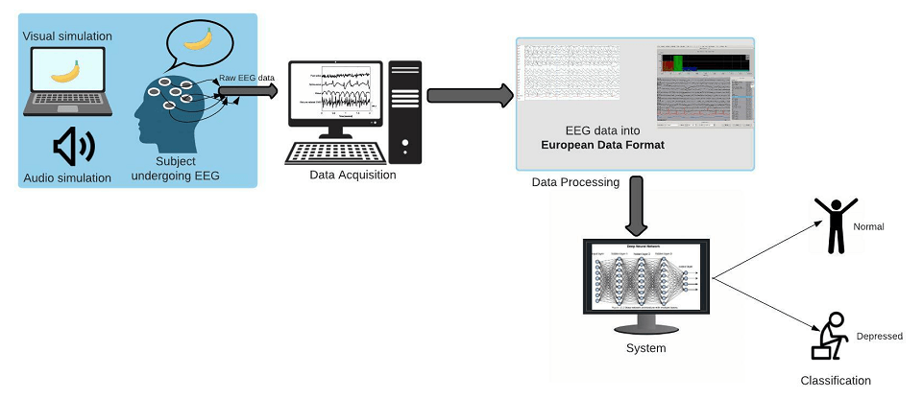

Prototype:
python 3.7.0 or 3.7.4
opencv-python==4.5.1.48
keras==2.3.1
tensorflow==1.14.0
protobuf==3.16.0
h5py==2.10.0
sklearn-extensions==0.0.2
scikit-learn==0.22.2.post1
Numpy
Pandas

Models and Diagrams:
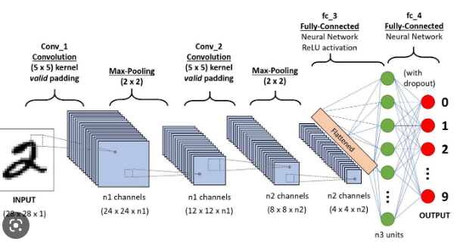

NON-FUNCTIONAL REQUIREMENT:
Usability: Usability is a quality attribute that assesses how easy user interfaces are to use. The word "usability" also refers to methods for improving ease-of-use during the design process.(how it was handle entire project easy)
Security: the quality or state of being secure: such as. a : freedom from danger : safety. b : freedom from fear or anxiety. c : freedom from the prospect of being laid off job security.
Readability: Readability is the ease with which a reader can understand a written text.
Performance: the execution of an action. : something accomplished : deed, feat. : the fulfillment of a claim, promise, or request : implementation. 3. : the action of representing a character in a play.
Availability: the quality or state of being available trying to improve the availability of affordable housing. 2 : an available person or thing.
Scalability: Scalability is the measure of a system's ability to increase or decrease in performance and cost in response to changes in application and system processing demands.
3.3. PROCESS MODEL USED WITH JUSTIFICATION
SDLC (Umbrella Model):
Umbrella Activity
Umbrella Activity
Umbrella Activity
- Feasibility Study
- TEAM FORMATION
- Project Specification PREPARATION

Business Requirement Documentation
ANALYSIS & DESIGN
CODE
UNIT TEST
DOCUMENT CONTROL

ASSESSMENT

TRAINING
INTEGRATION & SYSTEM TESTING

DELIVERY/INSTALLATION
ACCEPTANCE TEST
Requirements Gathering
SDLC is nothing but Software Development Life Cycle. It is a standard which is used by software industry to develop good software.
Stages in SDLC:
- Requirement Gathering
- Analysis
- Designing
- Coding
- Testing
- Maintenance
Requirements Gathering stage:
The requirements gathering process takes as its input the goals identified in the high-level requirements section of the project plan. Each goal will be refined into a set of one or more requirements. These requirements define the major functions of the intended application, define operational data areas and reference data areas, and define the initial data entities. Major functions include critical processes to be managed, as well as mission critical inputs, outputs and reports. A user class hierarchy is developed and associated with these major functions, data areas, and data entities. Each of these definitions is termed a Requirement. Requirements are identified by unique requirement identifiers and, at minimum, contain a requirement title and textual description.
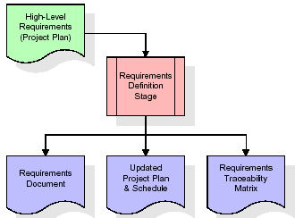
These requirements are fully described in the primary deliverables for this stage: the Requirements Document and the Requirements Traceability Matrix (RTM). The requirements document contains complete descriptions of each requirement, including diagrams and references to external documents as necessary. Note that detailed listings of database tables and fields are not included in the requirements document.
The title of each requirement is also placed into the first version of the RTM, along with the title of each goal from the project plan. The purpose of the RTM is to show that the product components developed during each stage of the software development lifecycle are formally connected to the components developed in prior stages.
In the requirements stage, the RTM consists of a list of high-level requirements, or goals, by title, with a listing of associated requirements for each goal, listed by requirement title. In this hierarchical listing, the RTM shows that each requirement developed during this stage is formally linked to a specific product goal. In this format, each requirement can be traced to a specific product goal, hence the term requirements traceability.
The outputs of the requirements definition stage include the requirements document, the RTM, and an updated project plan.
- Feasibility study is all about identification of problems in a project.
- No. of staff required to handle a project is represented as Team Formation, in this case only modules are individual tasks will be assigned to employees who are working for that project.
- Project Specifications are all about representing of various possible inputs submitting to the server and corresponding outputs along with reports maintained by administrator.
Analysis Stage:
The planning stage establishes a bird's eye view of the intended software product, and uses this to establish the basic project structure, evaluate feasibility and risks associated with the project, and describe appropriate management and technical approaches.
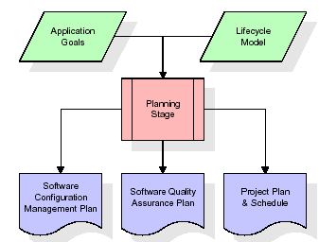
The most critical section of the project plan is a listing of high-level product requirements, also referred to as goals. All of the software product requirements to be developed during the requirements definition stage flow from one or more of these goals. The minimum information for each goal consists of a title and textual description, although additional information and references to external documents may be included. The outputs of the project planning stage are the configuration management plan, the quality assurance plan, and the project plan and schedule, with a detailed listing of scheduled activities for the upcoming Requirements stage, and high level estimates of effort for the out stages.
Designing Stage:
The design stage takes as its initial input the requirements identified in the approved requirements document. For each requirement, a set of one or more design elements will be produced as a result of interviews, workshops, and/or prototype efforts. Design elements describe the desired software features in detail, and generally include functional hierarchy diagrams, screen layout diagrams, tables of business rules, business process diagrams, pseudo code, and a complete entity-relationship diagram with a full data dictionary. These design elements are intended to describe the software in sufficient detail that skilled programmers may develop the software with minimal additional input.
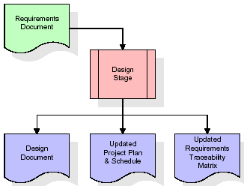
When the design document is finalized and accepted, the RTM is updated to show that each design element is formally associated with a specific requirement. The outputs of the design stage are the design document, an updated RTM, and an updated project plan.
Development (Coding) Stage:
The development stage takes as its primary input the design elements described in the approved design document. For each design element, a set of one or more software artifacts will be produced. Software artifacts include but are not limited to menus, dialogs, and data management forms, data reporting formats, and specialized procedures and functions. Appropriate test cases will be developed for each set of functionally related software artifacts, and an online help system will be developed to guide users in their interactions with the software.
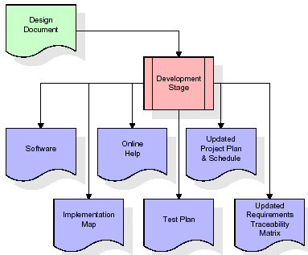

The RTM will be updated to show that each developed artifact is linked to a specific design element, and that each developed artifact has one or more corresponding test case items. At this point, the RTM is in its final configuration. The outputs of the development stage include a fully functional set of software that satisfies the requirements and design elements previously documented, an online help system that describes the operation of the software, an implementation map that identifies the primary code entry points for all major system functions, a test plan that describes the test cases to be used to validate the correctness and completeness of the software, an updated RTM, and an updated project plan.
Integration & Test Stage:
During the integration and test stage, the software artifacts, online help, and test data are migrated from the development environment to a separate test environment. At this point, all test cases are run to verify the correctness and completeness of the software. Successful execution of the test suite confirms a robust and complete migration capability. During this stage, reference data is finalized for production use and production users are identified and linked to their appropriate roles. The final reference data (or links to reference data source files) and production user list are compiled into the Production Initiation Plan.
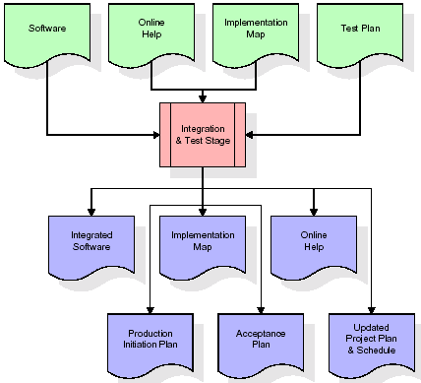
The outputs of the integration and test stage include an integrated set of software, an online help system, an implementation map, a production initiation plan that describes reference data and production users, an acceptance plan which contains the final suite of test cases, and an updated project plan.
- Installation & Acceptance Test:
During the installation and acceptance stage, the software artifacts, online help, and initial production data are loa ded onto the production server. At this point, all test cases are run to verify the correctness and completeness of the software. Successful execution of the test suite is a prerequisite to acceptance of the software by the customer.
After customer personnel have verified that the initial production data load is correct and the test suite has been executed with satisfactory results, the customer formally accepts the delivery of the software.
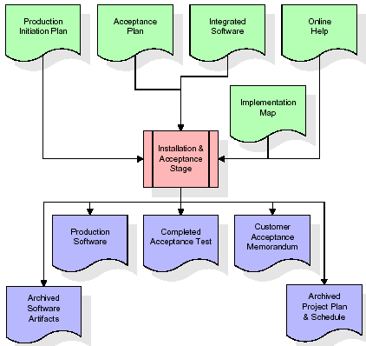
The primary outputs of the installation and acceptance stage include a production application, a completed acceptance test suite, and a memorandum of customer acceptance of the software. Finally, the PDR enters the last of the actual labor data into the project schedule and locks the project as a permanent project record. At this point the PDR "locks" the project by archiving all software items, the implementation map, the source code, and the documentation for future reference.
Maintenance:
Outer rectangle represents maintenance of a project, Maintenance team will start with requirement study, understanding of documentation later employees will be assigned work and they will undergo training on that particular assigned category. For this life cycle there is no end, it will be continued so on like an umbrella (no ending point to umbrella sticks).
3.4. Software Requirement Specification
3.4.1. Overall Description
A Software Requirements Specification (SRS) – a requirements specification for a software system is a complete description of the behavior of a system to be developed. It includes a set of use cases that describe all the interactions the users will have with the software. In addition to use cases, the SRS also contains non-functional requirements. Nonfunctional requirements are requirements which impose constraints on the design or implementation (such as performance engineering requirements, quality standards, or design constraints).
System requirements specification: A structured collection of information that embodies the requirements of a system. A business analyst, sometimes titled system analyst, is responsible for analyzing the business needs of their clients and stakeholders to help identify business problems and propose solutions. Within the systems development lifecycle domain, the BA typically performs a liaison function between the business side of an enterprise and the information technology department or external service providers. Projects are subject to three sorts of requirements:
- Business requirements describe in business terms what must be delivered or accomplished to provide value.
- Product requirements describe properties of a system or product (which could be one of several ways to accomplish a set of business requirements.)
- Process requirements describe activities performed by the developing organization. For instance, process requirements could specify .Preliminary investigation examine project feasibility, the likelihood the system will be useful to the organization. The main objective of the feasibility study is to test the Technical, Operational and Economical feasibility for adding new modules and debugging old running system. All system is feasible if they are unlimited resources and infinite time. There are aspects in the feasibility study portion of the preliminary investigation:
- ECONOMIC FEASIBILITY
A system can be developed technically and that will be used if installed must still be a good investment for the organization. In the economical feasibility, the development cost in creating the system is evaluated against the ultimate benefit derived from the new systems. Financial benefits must equal or exceed the costs. The system is economically feasible. It does not require any addition hardware or software. Since the interface for this system is developed using the existing resources and technologies available at NIC, There is nominal expenditure and economical feasibility for certain.
- Operational Feasibility
Proposed projects are beneficial only if they can be turned out into information system. That will meet the organization’s operating requirements. Operational feasibility aspects of the project are to be taken as an important part of the project implementation. This system is targeted to be in accordance with the above-mentioned issues. Beforehand, the management issues and user requirements have been taken into consideration. So there is no question of resistance from the users that can undermine the possible application benefits. The well-planned design would ensure the optimal utilization of the computer resources and would help in the improvement of performance status.
- TECHNICAL FEASIBILITY
Earlier no system existed to cater to the needs of ‘Secure Infrastructure Implementation System’. The current system developed is technically feasible. It is a web based user interface for audit workflow at NIC-CSD. Thus it provides an easy access to .the users. The database’s purpose is to create, establish and maintain a workflow among various entities in order to facilitate all concerned users in their various capacities or roles. Permission to the users would be granted based on the roles specified. Therefore, it provides the technical guarantee of accuracy, reliability and security.
3.4.2. External Interface Requirements
User Interface
The user interface of this system is a user friendly python Graphical User Interface.
Hardware Interfaces
The interaction between the user and the console is achieved through python capabilities.
Software Interfaces
The required software is python.
SYSTEM REQUIREMENT:
HARDWARE REQUIREMENTS:

Processor - Intel i3(min)
- Speed - 1.1 GHz
- RAM - 4GB(min)
- Hard Disk - 500 GB
- Key Board - Standard Windows Keyboard
- Mouse - Two or Three Button Mouse
- Monitor - SVGA
SOFTWARE REQUIREMENTS:
- Operating System - Windows10(min)
- Programming Language - Python

4. SYSTEM DESIGN
CLASS DIAGRAM:
The class diagram is the main building block of object oriented modeling. It is used both for general conceptual modeling of the systematic of the application, and for detailed modeling translating the models into programming code. Class diagrams can also be used for data modeling. The classes in a class diagram represent both the main objects, interactions in the application and the classes to be programmed. In the diagram, classes are represented with boxes which contain three parts:
- The upper part holds the name of the class
- The middle part contains the attributes of the class
- The bottom part gives the methods or operations the class can take or undertake

USECASE DIAGRAM:
A use case diagram at its simplest is a representation of a user's interaction with the system and depicting the specifications of a use case. A use case diagram can portray the different types of users of a system and the various ways that they interact with the system. This type of diagram is typically used in conjunction with the textual use case and will often be accompanied by other types of diagrams as we

SEQUENCE DIAGRAM
A sequence diagram is a kind of interaction diagram that shows how processes operate with one another and in what order. It is a construct of a Message Sequence Chart. A sequence diagram shows object interactions arranged in time sequence. It depicts the objects and classes involved in the scenario and the sequence of messages exchanged between the objects needed to carry out the functionality of the scenario. Sequence diagrams are typically associated with use case realizations in the Logical View of the system under development. Sequence diagrams are sometimes called event diagrams, event scenarios, and timing diagrams.
COLLABORATION DIAGRAM:
A collaboration diagram describes interactions among objects in terms of sequenced messages. Collaboration diagrams represent a combination of information taken from class, sequence, and use case diagrams describing both the static structure and dynamic behaviour of a system.

COMPONENT DIAGRAM:
In the Unified Modelling Language, a component diagram depicts how components are wired together to form larger components and or software systems. They are used to illustrate the structure of arbitrarily complex systems.
Components are wired together by using an assembly connector to connect the required interface of one component with the provided interface of another component. This illustrates the service consumer - service provider relationship between the two components.

DEPLOYMENT DIAGRAM:
A deployment diagram in the Unified Modeling Language models the physical deployment of artifacts on nodes. To describe a web site, for example, a deployment diagram would show what hardware components ("nodes") exist (e.g., a web server, an application server, and a database server), what software components ("artifacts") run on each node (e.g., web application, database), and how the different pieces are connected (e.g. JDBC, REST, RMI).
The nodes appear as boxes, and the artifacts allocated to each node appear as rectangles within the boxes. Nodes may have sub nodes, which appear as nested boxes. A single node in a deployment diagram may conceptually represent multiple physical nodes, such as a cluster of database servers.
ACTIVITY DIAGRAM:
Activity diagram is another important diagram in UML to describe dynamic aspects of the system. It is basically a flow chart to represent the flow form one activity to another activity. The activity can be described as an operation of the system. So the control flow is drawn from one operation to another. This flow can be sequential, branched or concurrent
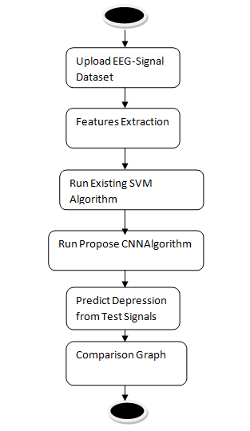
Data flow :
Data flow diagrams illustrate how data is processed by a system in terms of inputs and outputs. Data flow diagrams can be used to provide a clear representation of any business function. The technique starts with an overall picture of the business and continues by analyzing each of the functional areas of interest. This analysis can be carried out in precisely the level of detail required. The technique exploits a method called top-down expansion to conduct the analysis in a targeted way.
As the name suggests, Data Flow Diagram (DFD) is an illustration that explicates the passage of information in a process. A DFD can be easily drawn using simple symbols. Additionally, complicated processes can be easily automated by creating DFDs using easy-to-use, free downloadable diagramming tools. A DFD is a model for constructing and analyzing information processes. DFD illustrates the flow of information in a process depending upon the inputs and outputs. A DFD can also be referred to as a Process Model. A DFD demonstrates business or technical process with the support of the outside data saved, plus the data flowing from the process to another and the end results.
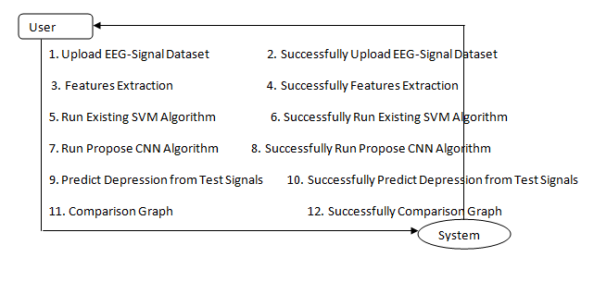
5. IMPLEMETATION
5.1 Python
Python is a general-purpose language. It has wide range of applications from Web development (like: Django and Bottle), scientific and mathematical computing (Orange, SymPy, NumPy) to desktop graphical user Interfaces (Pygame, Panda3D). The syntax of the language is clean and length of the code is relatively short. It's fun to work in Python because it allows you to think about the problem rather than focusing on the syntax.
History of Python:
Python is a fairly old language created by Guido Van Rossum. The design began in the late 1980s and was first released in February 1991.
Why Python was created?
In late 1980s, Guido Van Rossum was working on the Amoeba distributed operating system group. He wanted to use an interpreted language like ABC (ABC has simple easy-to-understand syntax) that could access the Amoeba system calls. So, he decided to create a language that was extensible. This led to design of a new language which was later named Python.
Why the name Python?
No. It wasn't named after a dangerous snake. Rossum was fan of a comedy series from late seventies. The name "Python" was adopted from the same series "Monty Python's Flying Circus".
Features of Python:
A simple language which is easier to learn
Python has a very simple and elegant syntax. It's much easier to read and write Python programs compared to other languages like: C++, Java, C#. Python makes programming fun and allows you to focus on the solution rather than syntax.
If you are a newbie, it's a great choice to start your journey with Python.
Free and open-source
You can freely use and distribute Python, even for commercial use. Not only can you use and distribute software’s written in it, you can even make changes to the Python's source code.
Python has a large community constantly improving it in each iteration.
Portability
You can move Python programs from one platform to another, and run it without any changes.
It runs seamlessly on almost all platforms including Windows, Mac OS X and Linux.
Extensible and Embeddable
Suppose an application requires high performance. You can easily combine pieces of C/C++ or other languages with Python code.
This will give your application high performance as well as scripting capabilities which other languages may not provide out of the box.
A high-level, interpreted language
Unlike C/C++, you don't have to worry about daunting tasks like memory management, garbage collection and so on.
Likewise, when you run Python code, it automatically converts your code to the language your computer understands. You don't need to worry about any lower-level operations.
Large standard libraries to solve common tasks
Python has a number of standard libraries which makes life of a programmer much easier since you don't have to write all the code yourself. For example: Need to connect MySQL database on a Web server? You can use MySQLdb library using import MySQLdb .
Standard libraries in Python are well tested and used by hundreds of people. So you can be sure that it won't break your application.
Object-oriented
Everything in Python is an object. Object oriented programming (OOP) helps you solve a complex problem intuitively.
With OOP, you are able to divide these complex problems into smaller sets by creating objects.
Applications of Python:
1. Simple Elegant Syntax
Programming in Python is fun. It's easier to understand and write Python code. Why? The syntax feels natural. Take this source code for an example:
a = 2
b = 3
sum = a + b
print(sum)
2. Not overly strict
You don't need to define the type of a variable in Python. Also, it's not necessary to add semicolon at the end of the statement.
Python enforces you to follow good practices (like proper indentation). These small things can make learning much easier for beginners.
3. Expressiveness of the language
Python allows you to write programs having greater functionality with fewer lines of code. Here's a link to the source code of Tic-tac-toe game with a graphical interface and a smart computer opponent in less than 500 lines of code. This is just an example. You will be amazed how much you can do with Python once you learn the basics.
4. Great Community and Support
Python has a large supporting community. There are numerous active forums online which can be handy if you are stuck.
5.2 Sample Code:
from tkinter import *
import tkinter
from tkinter import filedialog
import numpy as np
from tkinter import simpledialog
from tkinter import ttk
from tkinter.filedialog import askopenfilename
import matplotlib.pyplot as plt
import pandas as pd
import numpy as np
import os
from keras.models import Sequential
from sklearn.metrics import confusion_matrix
from sklearn.metrics import precision_score
from sklearn.metrics import recall_score
from sklearn.metrics import f1_score
from sklearn.metrics import accuracy_score
import seaborn as sns
from sklearn.model_selection import train_test_split
from sklearn.svm import SVC
from keras.utils.np_utils import to_categorical
from keras.layers import MaxPooling2D
from keras.layers import Dense, Dropout, Activation, Flatten
from keras.layers import Convolution2D
from keras.models import Sequential
from keras.models import model_from_json
import pickle

main = tkinter.Tk()
main.title("Depression Detection using EEG") #designing main screen
main.geometry("1000x650")

global dataset, X, Y, classifier
global X_train, X_test, y_train, y_test
global accuracy, precision, recall, fscore, cnn

def loadDataset():
global dataset
filename = filedialog.askopenfilename(initialdir="Dataset")
text.delete('1.0', END)
text.insert(END,filename+" loaded\n\n");
dataset = pd.read_csv(filename)
dataset.Label[dataset.Label == 2.0] = 1.0
label = dataset.groupby('Label').size()
label.plot(kind="bar")
plt.title("Total Normal & Depressed Records found in dataset 0 (Normal) & 1 (Depressed)")
plt.show()

def featuresExtraction():
global dataset, X, Y
global X_train, X_test, y_train, y_test
text.delete('1.0', END)
dataset.fillna(0, inplace = True)
dataset = dataset.values
X = dataset[:,0:dataset.shape[1]-1]
Y = dataset[:,dataset.shape[1]-1]
indices = np.arange(X.shape[0])
np.random.shuffle(indices)
X = X[indices]
Y = Y[indices]
print(Y)
text.insert(END,"Extracted Features from EEG Signals\n\n")
text.insert(END, str(X)+"\n\n")
text.insert(END,"Total features found in each records : "+str(X.shape[1])+"\n")
text.insert(END,"Total records found in dataset : "+str(X.shape[0])+"\n\n")
text.insert(END,"Dataset Train & Test Split Details. 80% dataset used for training & 20% dataset used for testing\n\n")

X_train, X_test, y_train, y_test = train_test_split(X, Y, test_size=0.2)
text.insert(END,"Total records used to train algorithms are : "+str(X_train.shape[0])+"\n")
text.insert(END,"Total records used to test algorithms are : "+str(X_test.shape[0])+"\n")

def calculateMetrics(algorithm, predict, testY):
p = precision_score(testY, predict,average='macro') * 100
r = recall_score(testY, predict,average='macro') * 100
f = f1_score(testY, predict,average='macro') * 100
a = accuracy_score(testY,predict)*100
conf_matrix = confusion_matrix(testY, predict)
text.insert(END,algorithm+' Accuracy : '+str(a)+"\n")
text.insert(END,algorithm+' Precision : '+str(p)+"\n")
text.insert(END,algorithm+' Recall : '+str(r)+"\n")
text.insert(END,algorithm+' FScore : '+str(f)+"\n\n")
accuracy.append(a)
precision.append(p)
recall.append(r)
fscore.append(f)
labels = ['Normal', 'Depressed']
plt.figure(figsize =(6, 6))
ax = sns.heatmap(conf_matrix, xticklabels = labels, yticklabels = labels, annot = True, cmap="viridis" ,fmt ="g");
ax.set_ylim([0,2])
plt.title(algorithm+" Confusion matrix")
plt.ylabel('True class')
plt.xlabel('Predicted class')
plt.show()

def runSVM():
global X_train, X_test, y_train, y_test
global accuracy, precision, recall, fscore
accuracy = []
precision = []
recall = []
fscore = []
text.delete('1.0', END)
svm_cls = SVC()
svm_cls.fit(X_train, y_train)
predict = svm_cls.predict(X_test)
calculateMetrics("SVM", predict, y_test)

def runCNN():
text.delete('1.0', END)
global X_train, X_test, y_train, y_test, X, Y, cnn
global accuracy, precision, recall, fscore
X = X[:,0:972]
XX = X.reshape(X.shape[0], 18, 18, 3)
YY = to_categorical(Y)
print(XX.shape)
X_train1, X_test1, y_train1, y_test1 = train_test_split(XX, YY, test_size=0.2)

if os.path.exists('model/model.json'):
with open('model/model.json', "r") as json_file:
loaded_model_json = json_file.read()
cnn = model_from_json(loaded_model_json)
json_file.close()
cnn.load_weights("model/model_weights.h5")
cnn._make_predict_function()
else:
cnn = Sequential()
cnn.add(Convolution2D(32, 3, 3, input_shape = (X_train1.shape[1], X_train1.shape[2], X_train1.shape[3]), activation = 'relu'))
cnn.add(MaxPooling2D(pool_size = (2, 2)))
cnn.add(Convolution2D(32, 3, 3, activation = 'relu'))
cnn.add(MaxPooling2D(pool_size = (2, 2)))
cnn.add(Flatten())
cnn.add(Dense(output_dim = 256, activation = 'relu'))
cnn.add(Dense(output_dim = y_test1.shape[1], activation = 'softmax'))
cnn.compile(optimizer = 'adam', loss = 'categorical_crossentropy', metrics = ['accuracy'])
hist = cnn.fit(X_train1, y_train1, batch_size=16, epochs=10, shuffle=True, verbose=2, validation_data=(X_test1, y_test1))
cnn.save_weights('model/model_weights.h5')
model_json = cnn.to_json()
with open("model/model.json", "w") as json_file:
json_file.write(model_json)
json_file.close()
f = open('model/history.pckl', 'wb')
pickle.dump(hist.history, f)
f.close()
print(cnn.summary())
predict = cnn.predict(X_test1)
predict = np.argmax(predict, axis=1)
testY = np.argmax(y_test1, axis=1)
calculateMetrics("CNN", predict, testY)

def predictDepression():
global cnn
labels = ["Normal", "Depressed"]
filename = filedialog.askopenfilename(initialdir="Dataset")
text.delete('1.0', END)
text.insert(END,filename+" loaded\n\n");
dataset = pd.read_csv(filename)
dataset = dataset.values
testData = dataset[:,0:972]
test_X = testData.reshape(testData.shape[0], 18, 18, 3)
predict = cnn.predict(test_X)
predict = np.argmax(predict, axis=1)
print(predict)
for i in range(len(testData)):
text.insert(END,str(testData[i])+" PREDICTED AS ====> "+labels[predict[i]]+"\n\n")

def graph():
df = pd.DataFrame([['SVM','Precision',precision[0]],['SVM','Recall',recall[0]],['SVM','F1 Score',fscore[0]],['SVM','Accuracy',accuracy[0]],
['CNN','Precision',precision[1]],['CNN','Recall',recall[1]],['CNN','F1 Score',fscore[1]],['CNN','Accuracy',accuracy[1]],

],columns=['Parameters','Algorithms','Value'])
df.pivot("Parameters", "Algorithms", "Value").plot(kind='bar')
plt.title("Existing SVM & Propose CNN Performance Graph")
plt.show()

def close():
main.destroy()

font = ('times', 16, 'bold')
title = Label(main, text='Depression Detection using EEG', justify=LEFT)
title.config(bg='lavender blush', fg='DarkOrchid1')
title.config(font=font)
title.config(height=3, width=120)
title.place(x=100,y=5)
title.pack()

font1 = ('times', 13, 'bold')
uploadButton = Button(main, text="Upload EEG-Signal Dataset", command=loadDataset)
uploadButton.place(x=10,y=100)
uploadButton.config(font=font1)

featuresButton = Button(main, text="Features Extraction", command=featuresExtraction)
featuresButton.place(x=330,y=100)
featuresButton.config(font=font1)

svmButton = Button(main, text="Run Existing SVM Algorithm", command=runSVM)
svmButton.place(x=680,y=100)
svmButton.config(font=font1)

cnnButton = Button(main, text="Run Propose CNN Algorithm", command=runCNN)
cnnButton.place(x=10,y=150)
cnnButton.config(font=font1)

predictButton = Button(main, text="Predict Depression from Test Signals", command=predictDepression)
predictButton.place(x=330,y=150)
predictButton.config(font=font1)

graphButton = Button(main, text="Comparison Graph", command=graph)
graphButton.place(x=680,y=150)
graphButton.config(font=font1)

closeButton = Button(main, text="Exit", command=close)
closeButton.place(x=880,y=150)
closeButton.config(font=font1)

font1 = ('times', 12, 'bold')
text=Text(main,height=20,width=120)
scroll=Scrollbar(text)
text.configure(yscrollcommand=scroll.set)
text.place(x=10,y=200)
text.config(font=font1)

main.config(bg='light coral')
main.mainloop()

6. TESTING:
Implementation and Testing:
Implementation is one of the most important tasks in project is the phase in which one has to be cautions because all the efforts undertaken during the project will be very interactive. Implementation is the most crucial stage in achieving successful system and giving the users confidence that the new system is workable and effective. Each program is tested individually at the time of development using the sample data and has verified that these programs link together in the way specified in the program specification. The computer system and its environment are tested to the satisfaction of the user.
Implementation
The implementation phase is less creative than system design. It is primarily concerned with user training, and file conversion. The system may be requiring extensive user training. The initial parameters of the system should be modifies as a result of a programming. A simple operating procedure is provided so that the user can understand the different functions clearly and quickly. The different reports can be obtained either on the inkjet or dot matrix printer, which is available at the disposal of the user. The proposed system is very easy to implement. In general implementation is used to mean the process of converting a new or revised system design into an operational one.

Testing
Testing is the process where the test data is prepared and is used for testing the modules individually and later the validation given for the fields. Then the system testing takes place which makes sure that all components of the system property functions as a unit. The test data should be chosen such that it passed through all possible condition. Actually testing is the state of implementation which aimed at ensuring that the system works accurately and efficiently before the actual operation commence. The following is the description of the testing strategies, which were carried out during the testing period.

System Testing
Testing has become an integral part of any system or project especially in the field of information technology. The importance of testing is a method of justifying, if one is ready to move further, be it to be check if one is capable to with stand the rigors of a particular situation cannot be underplayed and that is why testing before development is so critical. When the software is developed before it is given to user to use the software must be tested whether it is solving the purpose for which it is developed. This testing involves various types through which one can ensure the software is reliable. The program was tested logically and pattern of execution of the program for a set of data are repeated. Thus the code was exhaustively checked for all possible correct data and the outcomes were also checked.
Module Testing
To locate errors, each module is tested individually. This enables us to detect error and correct it without affecting any other modules. Whenever the program is not satisfying the required function, it must be corrected to get the required result. Thus all the modules are individually tested from bottom up starting with the smallest and lowest modules and proceeding to the next level. Each module in the system is tested separately. For example the job classification module is tested separately. This module is tested with different job and its approximate execution time and the result of the test is compared with the results that are prepared manually. The comparison shows that the results proposed system works efficiently than the existing system. Each module in the system is tested separately. In this system the resource classification and job scheduling modules are tested separately and their corresponding results are obtained which reduces the process waiting time.
Integration Testing
After the module testing, the integration testing is applied. When linking the modules there may be chance for errors to occur, these errors are corrected by using this testing. In this system all modules are connected and tested. The testing results are very correct. Thus the mapping of jobs with resources is done correctly by the system.

Acceptance Testing
When that user fined no major problems with its accuracy, the system passers through a final acceptance test. This test confirms that the system needs the original goals, objectives and requirements established during analysis without actual execution which elimination wastage of time and money acceptance tests on the shoulders of users and management, it is finally acceptable and ready for the operation.

Test Case Id | Test Case Name | Test Case Desc. | Test Steps |  |  |  | Test Case Status | Test Priority
 |  |  | Step | Expected |  | Actual
01 | Upload EEG-Signal Dataset | Verify Upload EEG-Signal Dataset or not | If Upload EEG-Signal Dataset may not upload | we cannot do any further operations | we can do further operations |  | High | High
02 | Features Extraction | Verify Features Extraction or not | If Features Extraction may not done | we cannot do any further operations | we can do further operations |  | High | High
03 | Run Existing SVM Algorithm | Verify Run Existing SVM Algorithm or not | If Run Existing SVM Algorithm May not be | we cannot do any further operations | we can do further operations |  | High | High
04 | Run Propose CNNAlgorithm | Verify Run Propose CNNAlgorithm or not | If Propose CNN Algorithm may not Run | We cannot run  operation | We can Run the Operation |  | High | High
05 | Predict Depression from Test Signals | Verify Predict Depression from Test Signals or not | If Predict Depression from Test Signals may not be | we cannot do any further operations | we can do further operations |  | High | High
06 | Comparison Graph | Verify Comparison Graph or not | If Comparison Graph may not be | we cannot do any further operations | we can do further operations |  | High | High
7. SCREENSHOTS:
To train CNN algorithm we have downloaded Depression EEG signals dataset from KAGGLE and below screen showing some dataset details
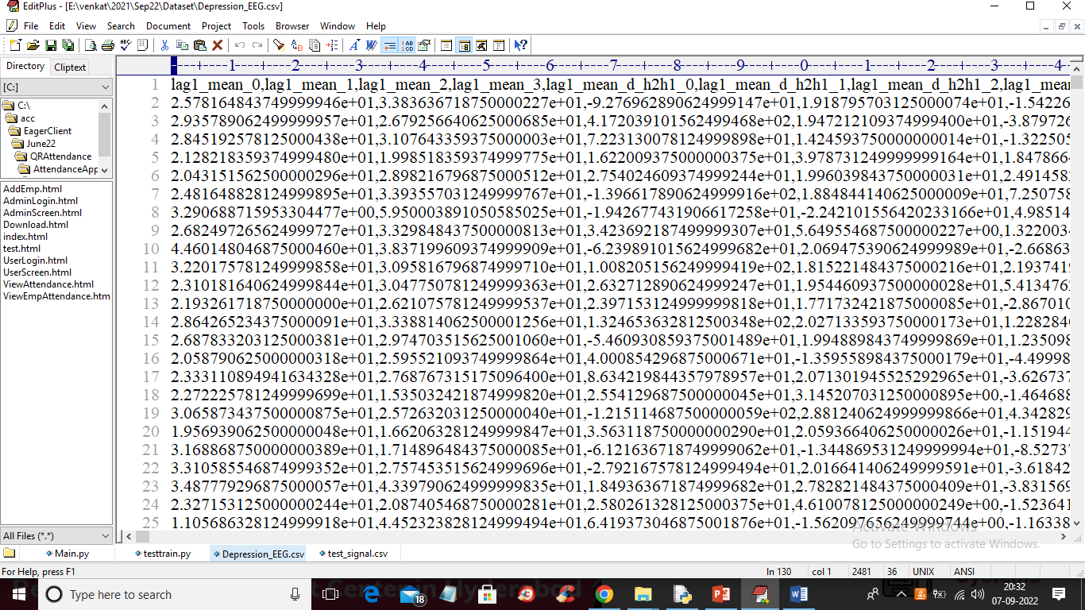
In above dataset screen first row represents dataset column names and remaining rows represents dataset values and this values are extracted from EEG signals and each rows contains 989 columns.
SCREENSHOTS
To run project double click on ‘run.bat’ file to get below screen
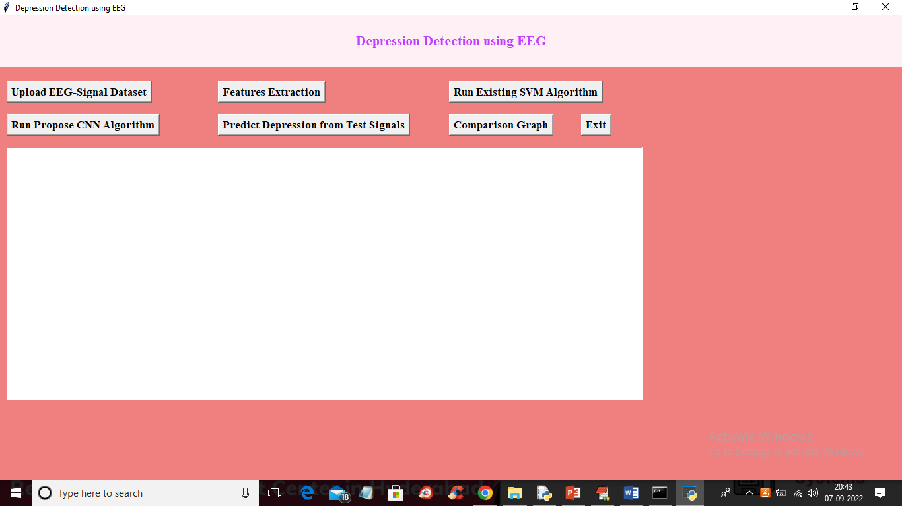
In above screen click on ‘Upload EEG-Signal Dataset’ button to upload dataset and get below output
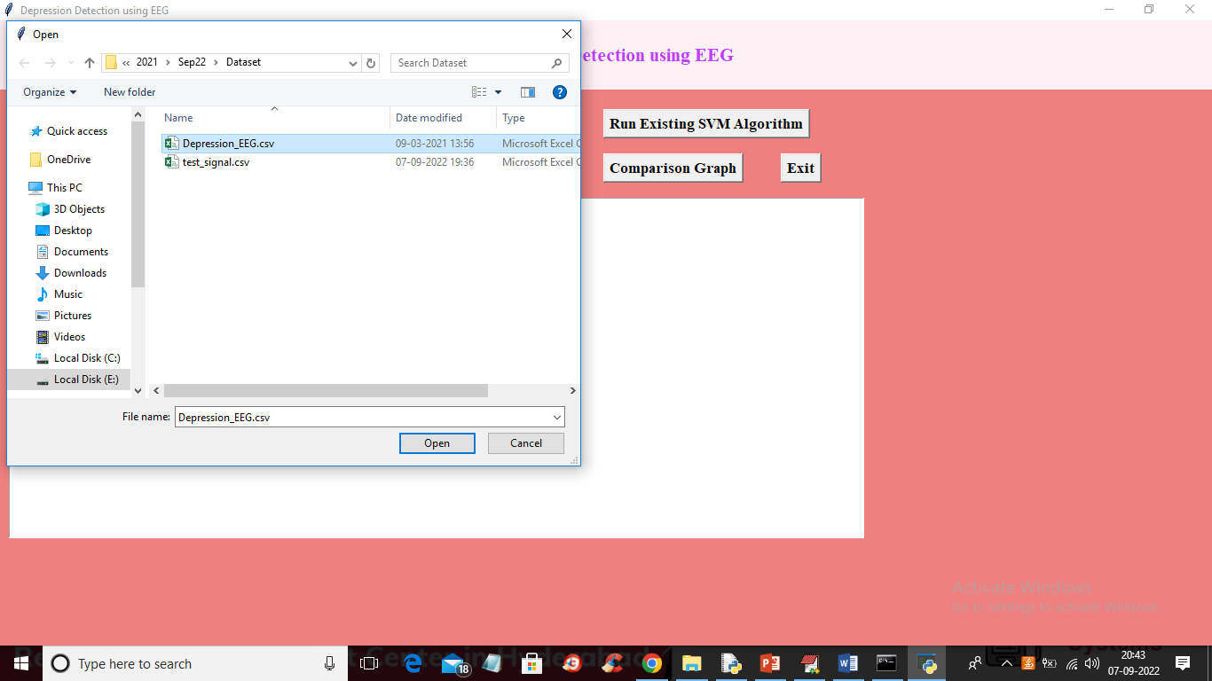
In above screen selecting and uploading EEG-Signal dataset and then click on ‘Open’ button to load dataset and get below output
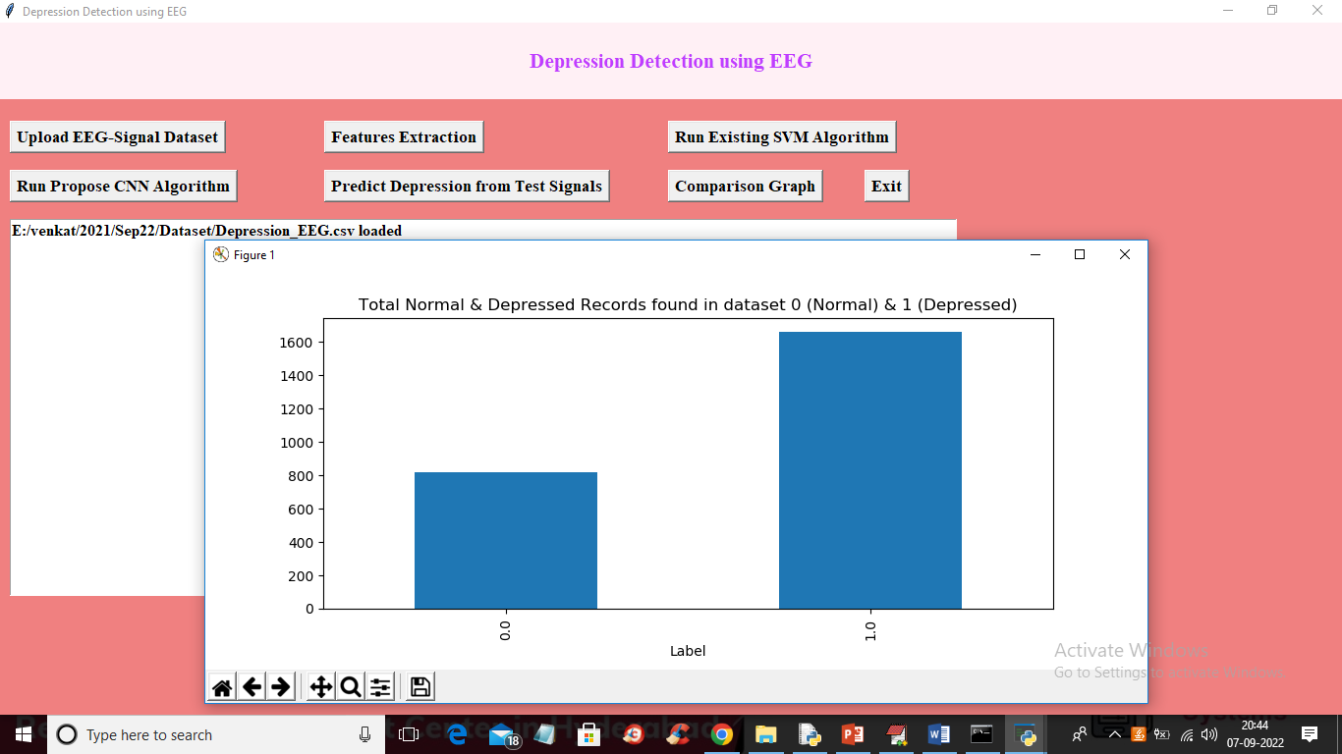
In above screen dataset loaded and in graph x-axis represents labels as 0 or 1 where 0 means Normal and 1 means Depressed and y-axis represents counts of records and now close above graph and then click on ‘Features Extraction’ button to extract features from the dataset and get below output
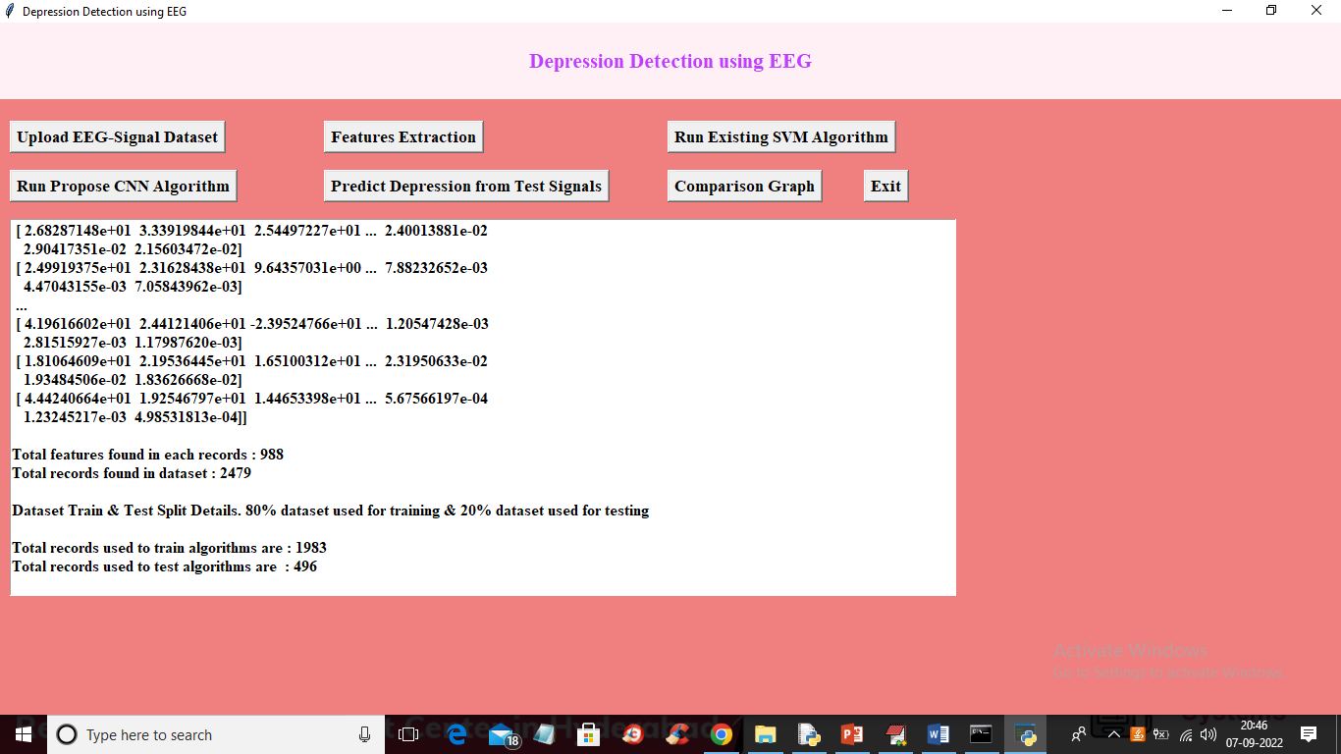
In above screen we can see extracted features and then each records contains 988 columns or features and dataset contains total records as 2479 and we can see train and test data details and now train and test data is ready for training. Now click on ‘Run Existing SVM Algorithm’ button to train SVM and get below output
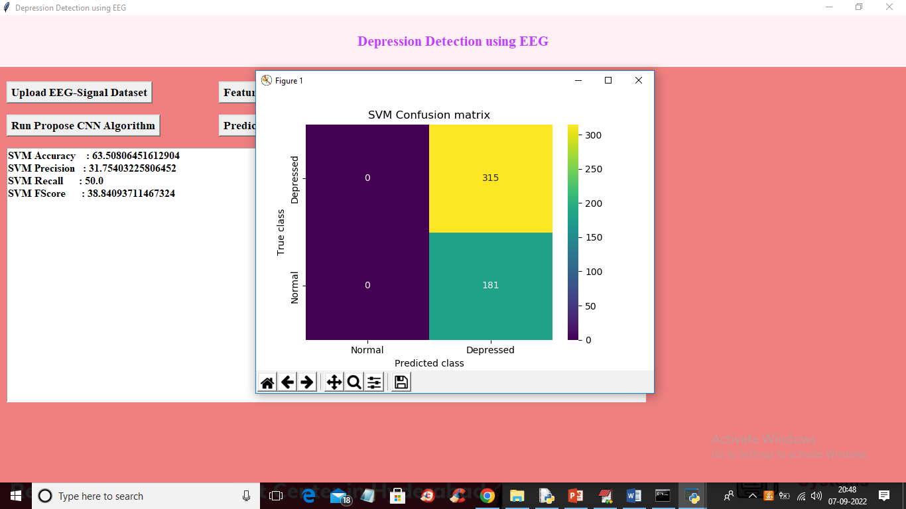
In above screen with SVM we got 63% accuracy and in confusion matrix graph x-axis represents Predicted classes and y-axis contains TRUE classes and we can see SVM predicted all records as Depressed and its performance is not good and now close above graph and then click on ‘Run Propose CNN Algorithm’ button to train CNN and get below output
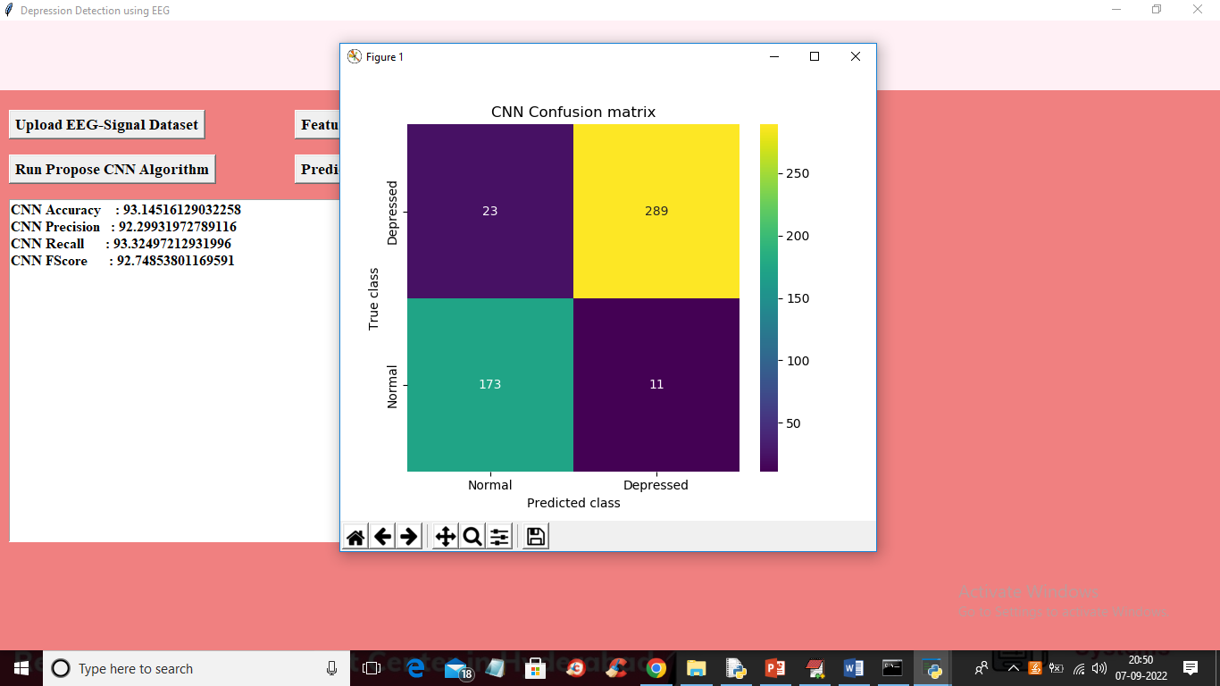
In above screen with CNN we got 93% accuracy and in confusion matrix graph different colour boxes represents CORRECT prediction count and same colour boxes represents INCORRECT prediction count and CNN predicted only 23 and 11 as wrong prediction and 173 and 289 as correct prediction. Now close above graph and then click on ‘Predict Depression from Test Signals’ button to upload test data and get prediction output
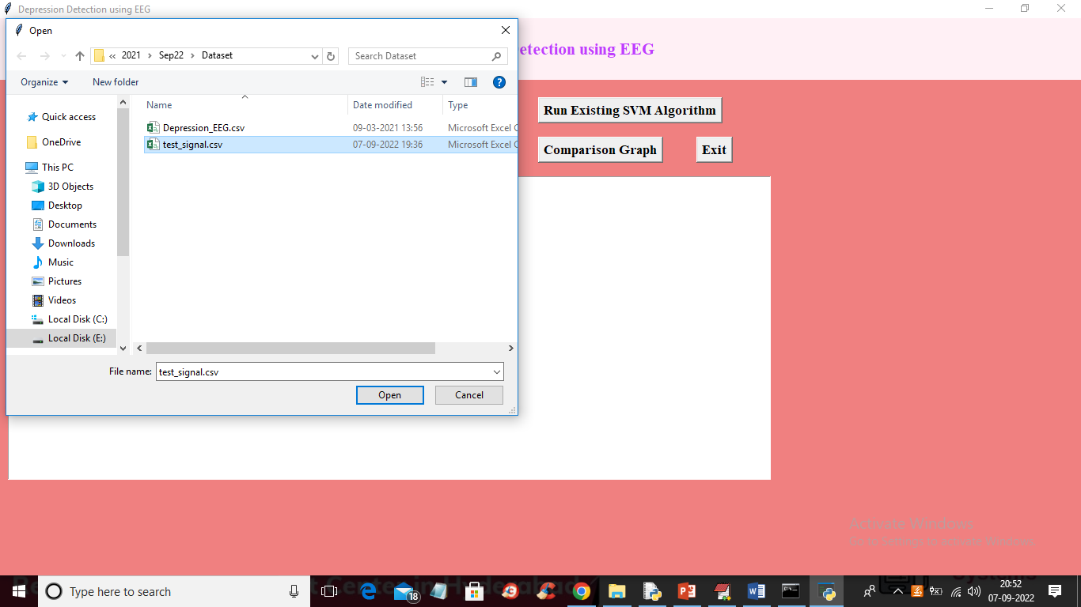
In above screen selecting and uploading ‘test_signal.csv’ file and then press Open button to load test data and get below prediction output
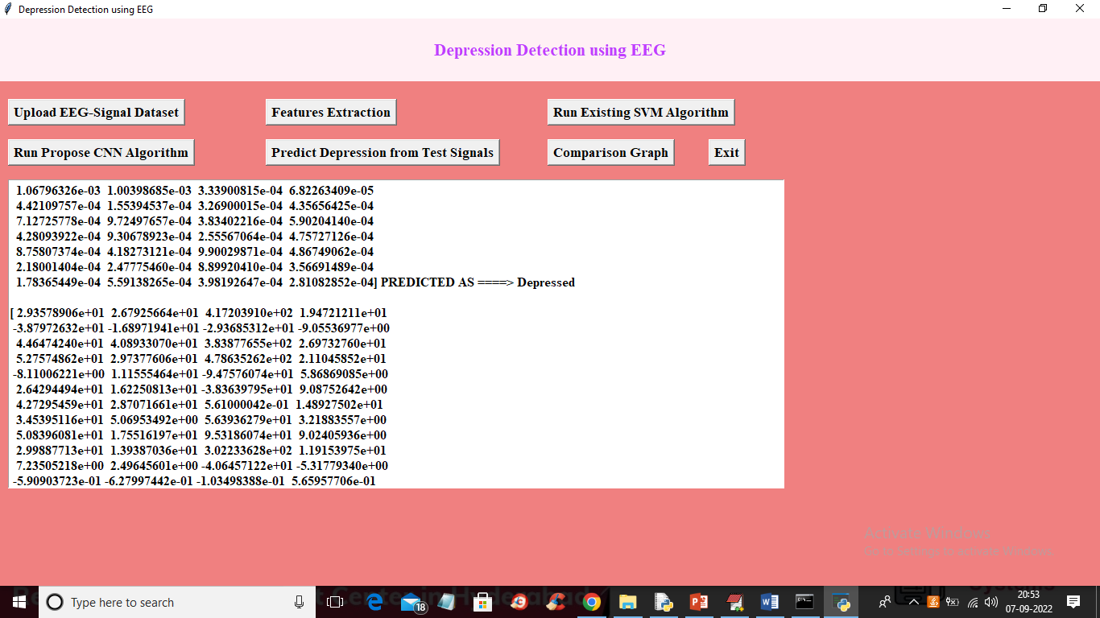
In above screen in square bracket we can see TEST data values and after = symbol we can see prediction as Depressed or Normal and you can scroll above output screen to view all prediction output like below screen
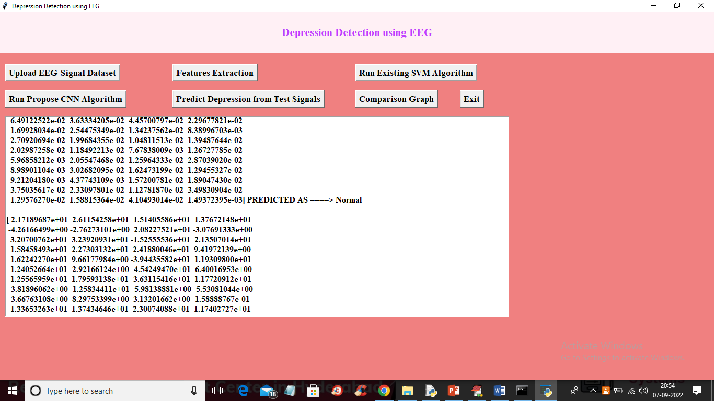
Now click on ‘Comparison Graph’ button to get below graph
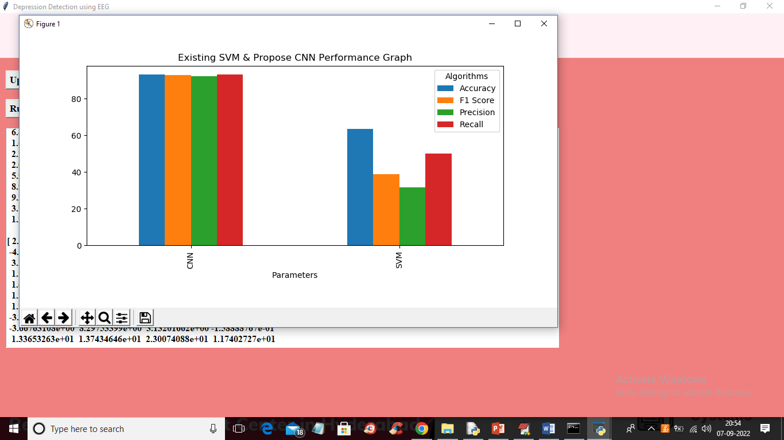
In above graph x-axis represents algorithm names and y-axis represents accuracy, precision, recall and FSCORE in different colour bars and in above graph we can see CNN got high values compare to SVM

8. CONCLUSION:
In this study, we present preliminary results for an auto-mated EEG classification system developed to classify EEGs with and without IEDs. It comprises of three main modules: pre-processing, waveform-level classification (CNN), and EEG-level classification (SVM)..In this project we are using deep learning CNN algorithm to predict depression from EEG signals dataset. Now-a-days humans are more prone to depression due to competitive environment in all fields and timely detection of depression can help humans in recovering faster. To predict depression accurately we are applying CNN algorithm which will filtered trained data at multiple layers to get optimized features which result into increase prediction accuracy. In our future work, we intend to incorporate artifact rejection in order to reduce the false detections. We also aim to modify the pre-processing module to adapt to different montages and EEG recording equipment
9. REFERENCES:

- Krizhevsky, A., Sutskever, I., and Hinton, G. E., ImageNet Classification with Deep Convolutional Neural Networks. Adv. Neural Inf. Proces. Syst., 2012. https://doi.org/10.1016/j.protcy.2014.09.007.
- Szegedy, C., Liu, W., Jia, Y., Sermanet, P., Reed, S., Anguelov, D., Erhan, D., Vanhoucke, V., Rabinovich, A., Going deeper with convolutions. In: Proceedings of the IEEE Computer Society Conference on Computer Vision and Pattern Recognition, 2015.
- Simonyan, K., Zisserman, A., Very deep convolutional networks for large-scale image recognition. arXiv preprint arXiv:1409.1556, 2014.
- LeCun, Y., Bottou, L., Bengio, Y., and Haffner, P., Gradient-based learning applied to document recognition. Proc. IEEE 86:2278–2323, 1998. https://doi.org/10.1109/5.726791.
- Bashivan, P., Rish, I., Yeasin, M., and Codella, N., Learning representations from EEG with deep recurrent-convolutional neural networks. arXiv preprint arXiv:1511.06448, 2015.
- Talo, M., Baloglu, U. B., Yildirim, O., and Acharya, U. R., Application of deep transfer learning for automated brain abnormality classification using MR images. Cogn. Syst. Res., 2018. https://doi.org/10.1016/j.cogsys.2018.12.007.
- Bhat, S., Acharya, U. R., Hagiwara, Y., Dadmehr, N., and Adeli, H., Parkinson’s disease: Cause factors, measurable indicators, and early diagnosis. Comput. Biol. Med., 2018. https://doi.org/10.1016/j.compbiomed.2018.09.008.
- Acharya, U. R., Vinitha Sree, S., Swapna, G., Martis, R. J., and Suri, J. S., Automated EEG analysis of epilepsy: A review. Knowledge-Based Syst 45:147–165, 2013. https://doi.org/10.1016/j.knosys.2013.02.014.

- Janga Vijaykumar, P., and Sreenivasareddy, E., A review on Machine Learning Techniques for Neurological disorders estimation by Analyzing EEG Waves. Int J Trend Sci Res Dev., 2018.
- Acharya, U. R., Hagiwara, Y., Deshpande, S. N., Suren, S., Koh, J. E. W., Oh, S. L., Arunkumar, N., Ciaccio, E. J., and Lim, C. M., Characterization of focal EEG signals: A review. Futur. Gener. Comput. Syst., 2019. https://doi.org/10.1016/j.future.2018.08.044.

- Petrosian, A., Prokhorov, D., Homan, R., Dasheiff, R., and Wunsch, D., Recurrent neural network based prediction of epileptic seizures in intra- and extracranial EEG. Neurocomputing., 2000. https://doi.org/10.1016/S0925-2312(99)00126-5.
- Mirowski, P., Madhavan, D., LeCun, Y., and Kuzniecky, R., Classification of patterns of EEG synchronization for seizure prediction. Clin. Neurophysiol., 2009. https://doi.org/10.1016/j.clinph.2009.09.002.
- Acharya, U. R., Oh, S. L., Hagiwara, Y., Tan, J. H., and Adeli, H., Deep convolutional neural network for the automated detection and diagnosis of seizure using EEG signals. Comput. Biol. Med. 100:270–278, 2018.
- Wulsin, D. F., Gupta, J. R., Mani, R., Blanco, J. A., and Litt, B., Modeling electroencephalography waveforms with semi-supervised deep belief nets: Fast classification and anomaly measurement. J. Neural Eng., 2011. https://doi.org/10.1088/1741-2560/8/3/036015.

- Stober, S., Sternin, A., Owen, A. M., and Grahn, J. A., Deep feature learning for EEG recordings. arXiv preprint arXiv:1511.04306, 2015.
- Yıldırım, Ö., Baloglu, U. B., and Acharya, U. R., A deep convolutional neural network model for automated identification of abnormal EEG signals. Neural Comput. & Applic.:1–12, 2018.

